AUTONOMOUS WEED REMOVAL ROBOT
Using Delta Mechanism Mounted on Omnidirectional Mobile Platform
Delta Robot Subsystem — Kinematics, Workspace, and Control (Simulation Study)

1. Problem Statement
Precision weed removal on a mobile agricultural platform requires the end-effector to reach small, unpredictably located targets within a bounded work volume and return to a home position quickly enough to keep pace with continuous field traversal. A delta robot is well suited to this role — motors stay fixed at the base, minimizing moving mass and enabling fast, repeatable positioning compared to a serial-link arm.
This subsystem design has to satisfy four requirements before it can be trusted as part of a larger system:
1. Kinematic consistency. The controller commands joint angles derived from inverse kinematics (IK), but planning and verification require converting joint angles back to Cartesian position via forward kinematics (FK). If IK and FK do not agree, position error compounds silently through the control loop.
2. Workspace coverage. With a fixed arm geometry, the reachable volume is finite. The subsystem must reach every point across the platform's operating footprint, and that footprint has to be characterized, not assumed.
3. Multi-target efficiency. A single pass may detect several weeds; visiting order affects total cycle time and energy use.
4. Actuator response. Each joint must settle at a commanded angle within the cycle-time budget without excessive overshoot, which risks damaging adjacent crops.

2. Methodology

2.1 Geometry
The robot follows Clavel's standard parallel-delta configuration: an equilateral base platform (side sb = 150 mm) and end-effector platform (side sp = 50 mm), connected by three identical limbs, each consisting of an upper arm (L = 120 mm, actuated) and a lower arm (l = 230 mm, passive parallelogram). The apothems wb, wp of the two triangles combine into an effective radius offset a = wb − wp used throughout the kinematic equations.

2.2 Inverse Kinematics
For a target (x, y, z), each leg's angle is solved independently by rotating the target into that leg's local YZ-plane (±120° per leg) and solving the resulting circle–sphere intersection analytically, yielding a closed-form quadratic in the tangent half-angle.

2.3 Forward Kinematics
Given three joint angles, each leg's wrist position is computed directly from arm geometry. The end-effector position is then found via trilateration — the point equidistant (by the lower-arm length l) from all three wrist points — solved as a linear system reduced to a single quadratic in z.

2.4 Validation Approach
IK and FK were tested against each other directly: a set of target points spanning the workspace were passed through IK, and the resulting joint angles passed back through FK. Recovered position error was measured against the original target.

2.5 Workspace Characterization
The reachable volume was estimated by exhaustive numerical sampling — a 20×20×20 grid spanning ±250 mm in X/Y and −50 mm to −250 mm in Z — retaining only points where all three legs return a valid IK solution. Maximum radial reach was computed from this sample set and overlaid on the 3D scatter as a boundary reference.

2.6 Trajectory Planning
For a set of detected weed coordinates, a greedy nearest-neighbor heuristic sequences visits starting and ending at the home position. This was benchmarked against the unsorted detection order as a baseline to quantify the benefit of sequencing.

2.7 Actuator Dynamics
Joint response was modeled as a second-order system — commanded torque (from a PID controller, saturated at estimated actuator stall torque) driving angular acceleration through rotational inertia J and viscous damping b. J combines an analytically derived arm-rod inertia term (J = ⅓·m·L², assuming a ~0.1 kg arm) with an estimated multiplier accounting for unmodeled reflected gearbox and lower-arm loading; this multiplier is an engineering estimate, not a separately derived value. b is estimated from a representative hobby servo's datasheet ratio of stall torque to no-load speed.

2.8 Scope Note
This subsystem was developed and validated entirely in simulation; no physical actuator or prototype was tested. All figures and tables in this section reflect simulated results.

2.9 Sensitivity Analysis Across Randomized Layouts
Section 3.2's cycle-time and path-reduction figures come from one fixed 5-weed layout, which is enough to demonstrate the pipeline but not enough to say how it behaves in general. To check that, camera-frame weed detections were generated in batches of independent random scenarios — each scenario drawing a random weed count (3–8) and random detection coordinates inside the camera's field of view, with a minimum inter-weed spacing enforced so targets don't overlap. Each scenario was pushed through the same detection-to-cycle-time pipeline used elsewhere in this section: camera-to-robot-frame transform, per-point reachability check, greedy nearest-neighbor ordering, and cycle-time estimation. Twenty-five scenarios were generated this way (seed = 100, for reproducibility), and cycle time and path-length reduction were recorded per scenario rather than just once.
As a reproducibility measure that came out of building this batch generator, every tunable constant used across the kinematics, integration, and test-data modules — arm geometry, joint limits, the operating envelope, PID gains, cycle-time parameters — was consolidated into a single configuration module that the rest of the code imports from, rather than being redefined per-file. A small set of regression checks (round-trip IK/FK error, a known-unreachable point, joint-limit enforcement, and the minimum weed-spacing constraint) now runs in one command as well, so a change to the kinematics that breaks an existing guarantee is caught immediately rather than surfacing later as an unexplained result.

3. Results

3.1 IK/FK Round-Trip Validation
Table 1 reports recovered position error after passing a set of target points through inverse kinematics and then forward kinematics.
Target (x, y, z) mm | Recovered (x, y, z) mm | Error (mm)
(0, 0, -150) | (0.000000, 0.000000, -150.000000) | 5.75×10⁻¹⁴
(20, 30, -150) | (20.000000, 30.000000, -150.000000) | 5.42×10⁻¹⁴
(-90, 60, -160) | (-90.000000, 60.000000, -160.000000) | 4.02×10⁻¹⁴
(80, 20, -180) | (80.000000, 20.000000, -180.000000) | 8.11×10⁻¹⁴
(10, -90, -200) | (10.000000, -90.000000, -200.000000) | 2.86×10⁻¹⁴
(100, -50, -190) | (100.000000, -50.000000, -190.000000) | 2.13×10⁻¹⁴
(-80, -90, -170) | (-80.000000, -90.000000, -170.000000) | 2.49×10⁻¹³
(150, 0, -200) | (150.000000, 0.000000, -200.000000) | 5.88×10⁻¹⁴
(0, 150, -160) | (0.000000, 150.000000, -160.000000) | 9.25×10⁻¹⁴
(-100, 100, -210) | (-100.000000, 100.000000, -210.000000) | 7.65×10⁻¹⁴
Maximum error across all sampled points: 2.49×10⁻¹³ mm; mean error: 7.60×10⁻¹⁴ mm — consistent with floating-point precision limits, confirming IK and FK are analytically consistent across the sampled workspace.

3.2 Summary Results
Metric | Value
Reachable workspace radius | 253.1 mm
Path length — greedy nearest-neighbor | 758.2 mm
Path length — unsorted detection order | 990.1 mm
Trajectory length reduction | 23.4%
Joint angle setpoint | 45.0°
Settled joint angle at t = 0.5 s | 45.3°

3.3 Sensitivity Results Across Randomized Layouts
Table 3 summarizes cycle time and path-length reduction across the 25 randomized scenarios described in Section 2.9. Reachability also varied by scenario, since randomly placed weeds occasionally fall outside the operating envelope: of 133 total weeds generated across all scenarios, 113 (85.0%) were reachable without repositioning the mobile base.
Statistic (n = 25 scenarios) | Cycle time (s) | Path length reduction (%)
Mean | 3.10 | 18.7
Std. dev. | 0.99 | 17.0
Min | 1.23 | -5.9
Max | 4.88 | 45.9

The single fixed-layout example in Table 2 (23.4% reduction) sits inside this spread but isn't representative of it on its own — path-length reduction ranged from a 5.9% loss (greedy ordering performing worse than the arbitrary detection order, which happens occasionally in small, sparse scenarios) up to a 45.9% reduction in larger, denser ones. Cycle time scaled with reachable weed count as expected, from 1.23 s up to 4.88 s across the batch.
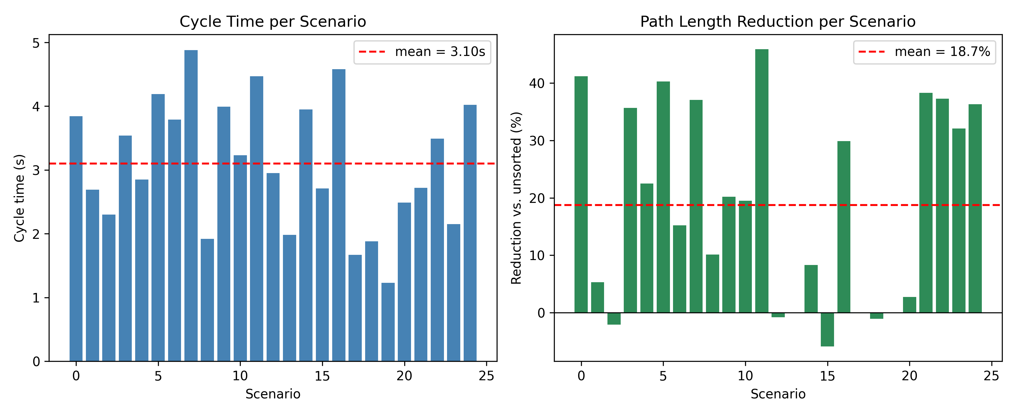
Figure 4a. Cycle time and path-length reduction across 25 randomized weed-detection scenarios (seed = 100), with the mean shown as a dashed line in each panel.

3.4 Figures
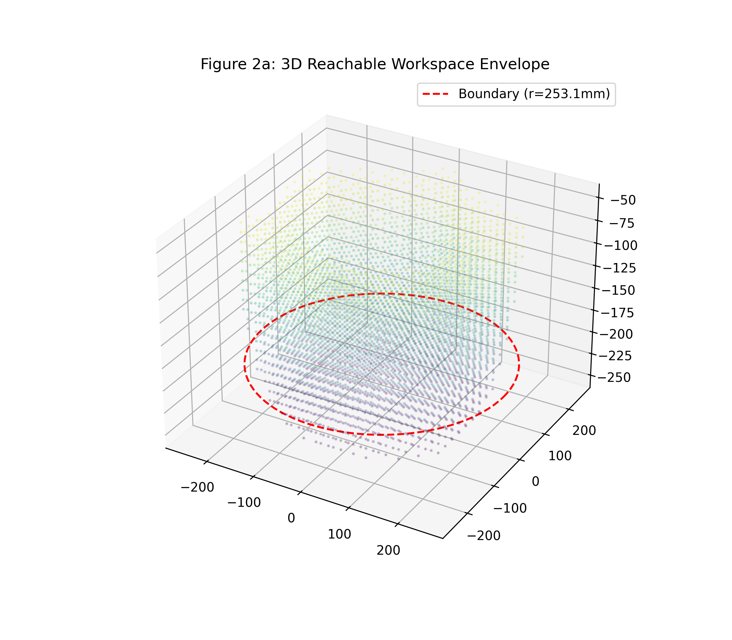
Figure 2a. 3D reachable workspace, sampled points colored by depth, with computed 253.1 mm boundary overlaid.
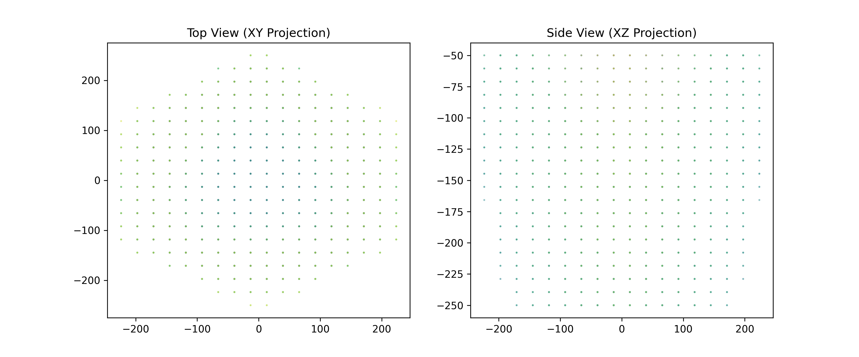
Figure 2b. Top (XY) and side (XZ) projections of the same workspace sample.
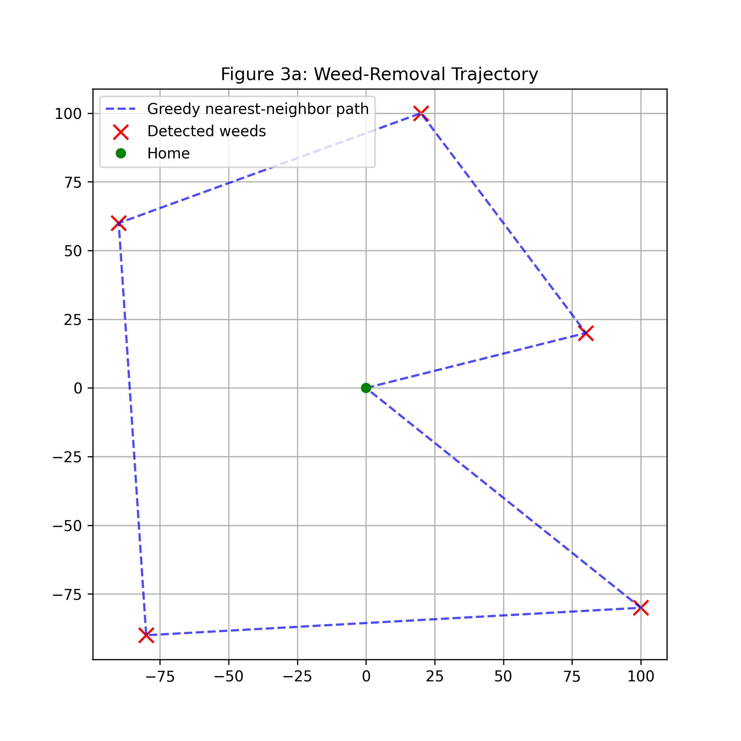
Figure 3a. Greedy nearest-neighbor trajectory across five detected weed positions, home-to-home.
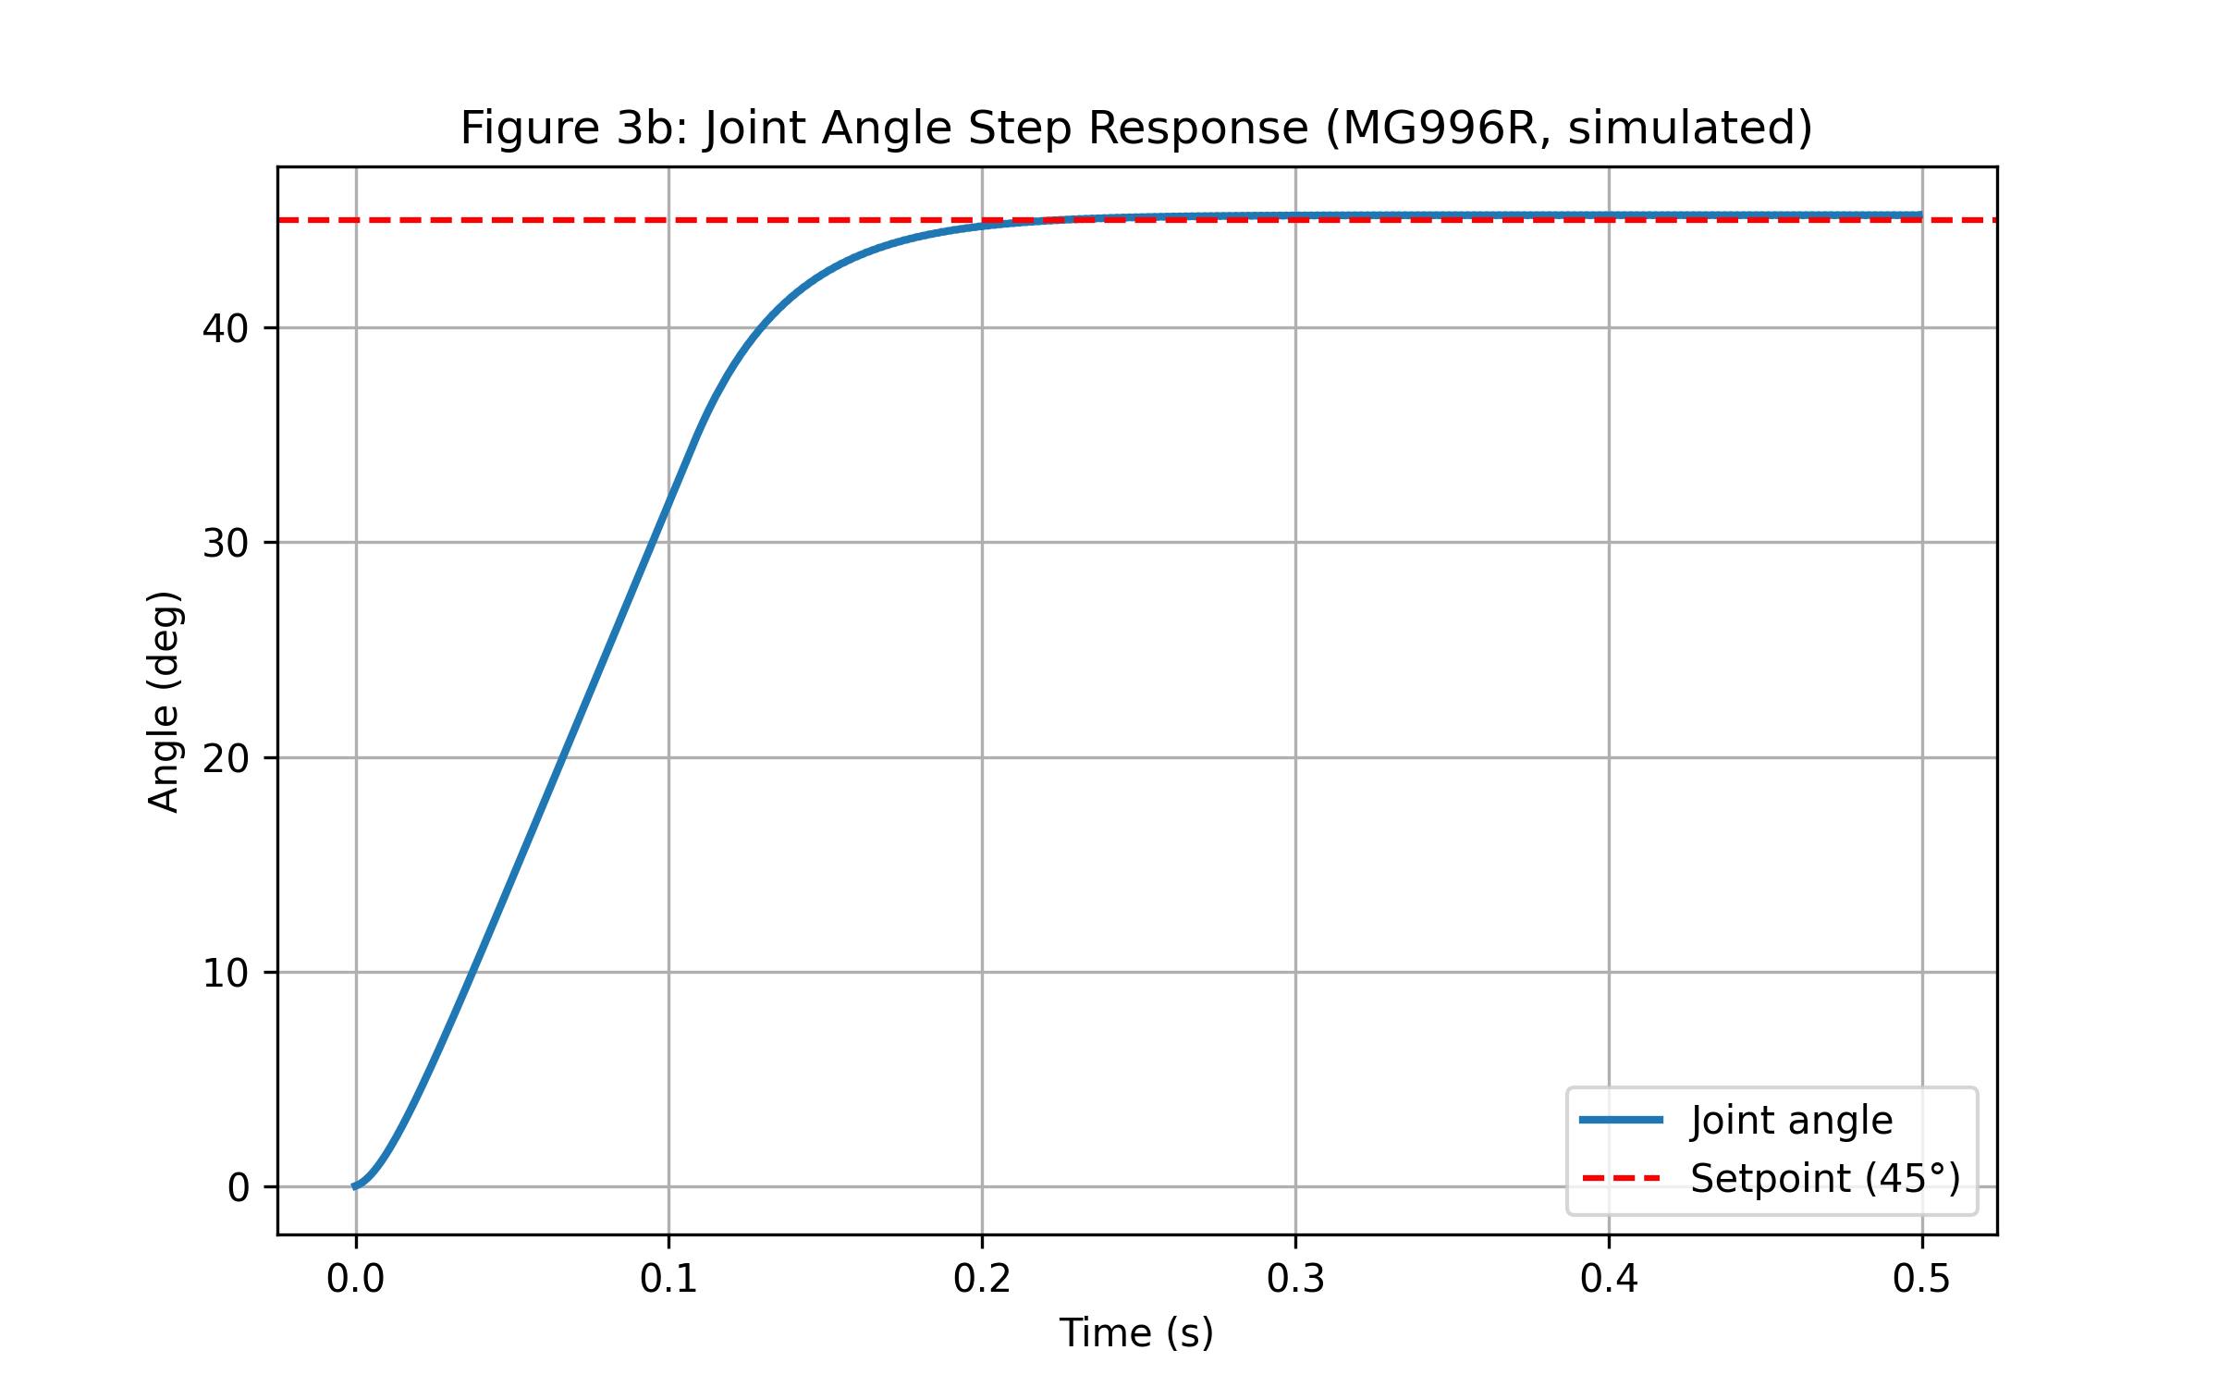
Figure 3b. Simulated joint-angle step response under PID control, settling near the 45° setpoint within the 0.5 s window with a small realistic overshoot.

